Weekly NSP Website Data Analytics Standards of Practice

Contents
Weekly NSP Website Data Analytics Standards of Practice 1
Overview 1
Public Website Data 2
Employee Website Data 6
Pulling Subscriber Data 8
Retrieving Newsletter Performance Reports 8
Updating Takeaways 11

Overview
The Communications Team extracts reports from Google Analytics and the Employee SharePoint site to support the PowerBI NSP Websites Dashboard. Reports are extracted weekly (typically Tuesday mornings) and key takeways should be sent to the IT Team (Curtis Sun/Jay Henrie) by Tuesday COB.
The remainder of this document details the steps for setting up Google Analytics, extracting data for the Employee SharePoint, Public website, newsletter subscribers, and determining key takeaways for reporting.
A recording of this training can be viewed here: Data Analytics Recording-20241119_093212-Meeting Recording.mp4

Public Website Data
- Accessing Google Analytics
  - Go to Gaining Access to the Data | Office of Information and Technology (va.gov) and follow the steps there to associate your VA email address with a Google account.
  - Once the Google Account is created, go to DAP Access Request | Office of Information and Technology (va.gov) and fill out the form requesting access to the public NSP website: https://www.va.gov/STANDARDSOFPRACTICE/
  - Once granted access to the Google Analytics site from the Digital Analytics Program (DAP), go to Analytics 360 (google.com).
  - Select Government-Wide Account
    - Select GA4 – Gov-Wide DAP Property (Figure 1)
    - Select Veterans Affairs Agency (Figure 2)
Figure 1
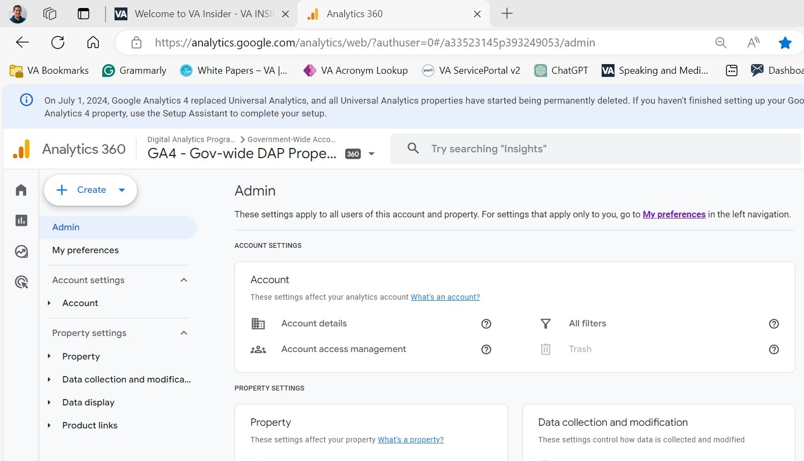

Figure 2
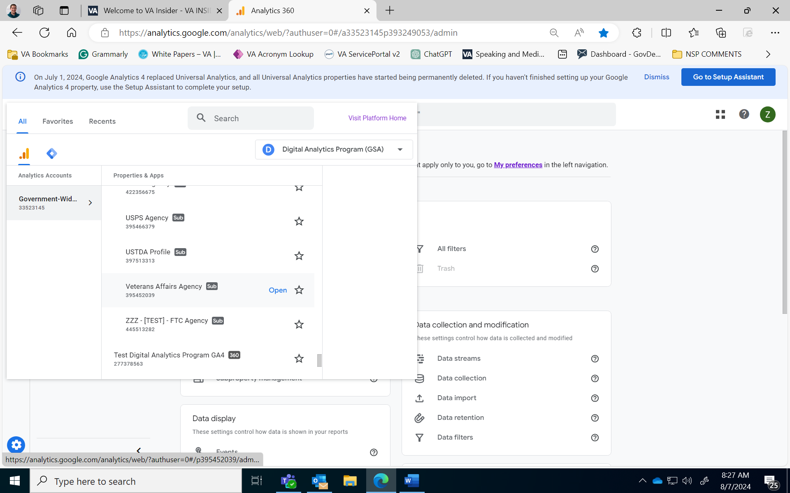
- Pulling the analytics report
  - Once the right account is selected, click reports on the left side of the screen. (Figure 3)
Figure 3
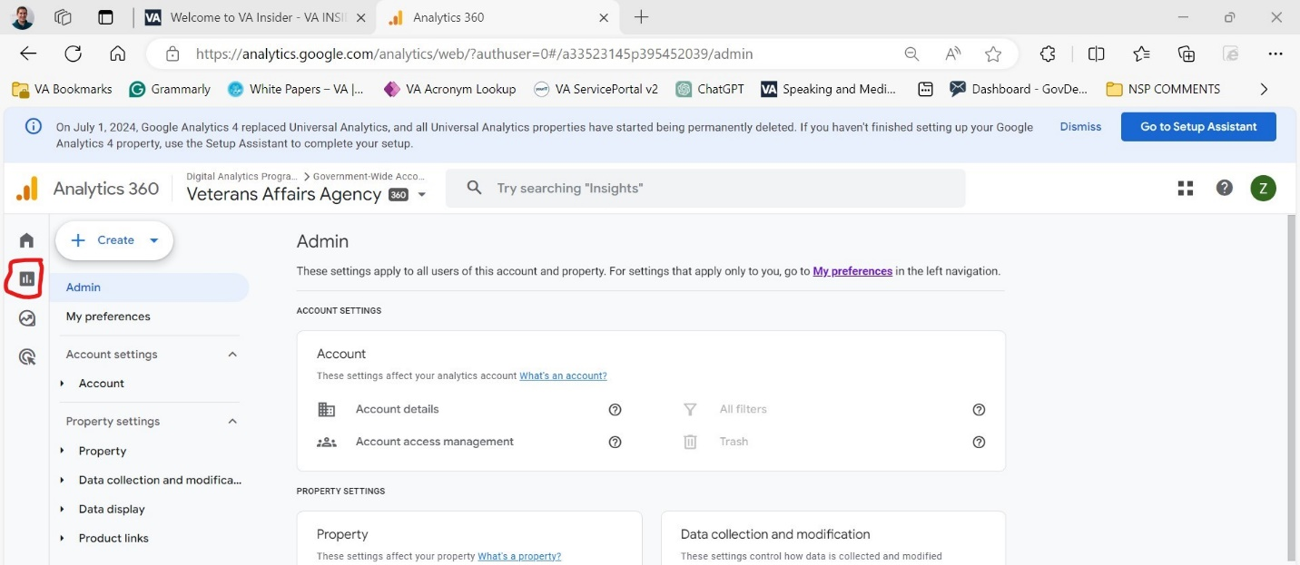
  - Click detailed reports on the left-hand side and select the “all pages” option. (Figure 4)
Figure 4
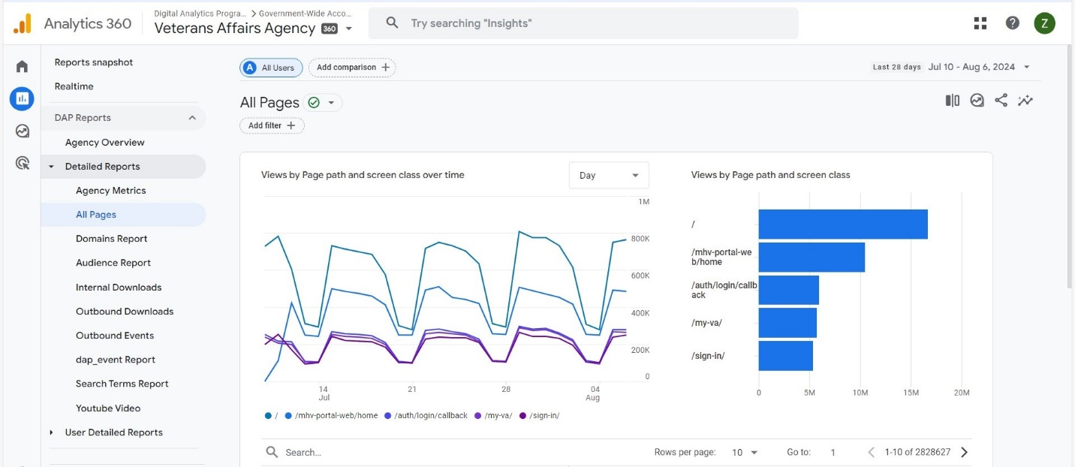
  - In the search bar beneath the line graph type “standardsofpractice” and press the enter. key. (Figure 5)
  - In the top right corner, change the window of time to the Tuesday 7 days prior to today. (Figure 5)
Figure 5
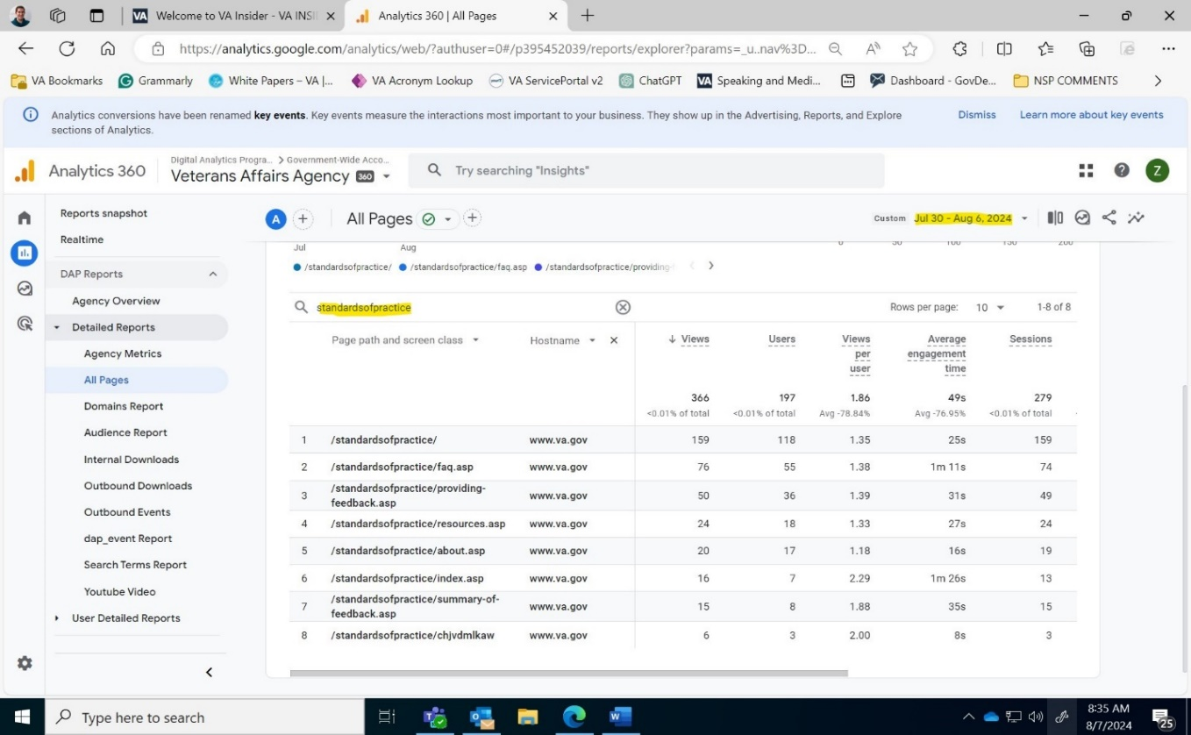
  - Click “share this report”. (Figure 6)
    - Click “download file”
      - Click “download CSV”(Figure 6)
Figure 6
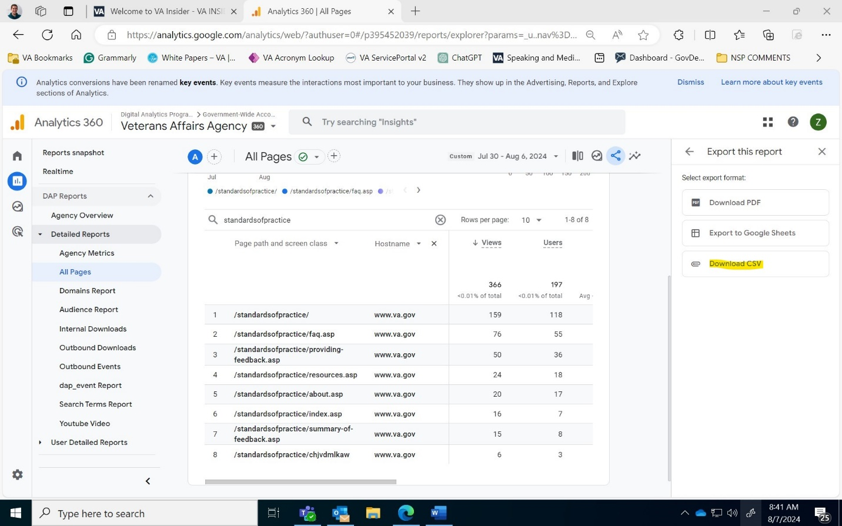
  - Save the exported file as SiteAnalyticsDatapublic_XX-MONTH,YEAR
- Importing Public Website Data
  - Input the new data from the pulled report into the PowerBI Template.
    - NOTE: The total amount of views and unique users is only listed on the Google Analytics page itself.
  - Copy and paste the prior week’s total views and unique user count into the Archive tab.
  - Upload the SiteAnalytics document into the NSP Public Website Data folder.

Employee Website Data
- Accessing and downloading analytics from the employee website
  - From the NSP employee engagement home page select settings (gear icon) and click site usage (Figure 7)

Figure 7
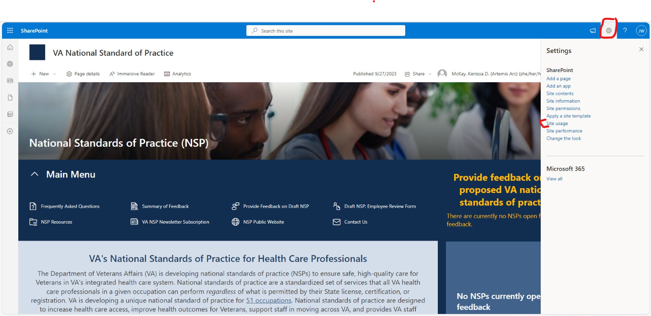

  - Ensure Last 7 days is highlighted and click on the arrow to download 7 days of usage data. (Figure 8)
Figure 8
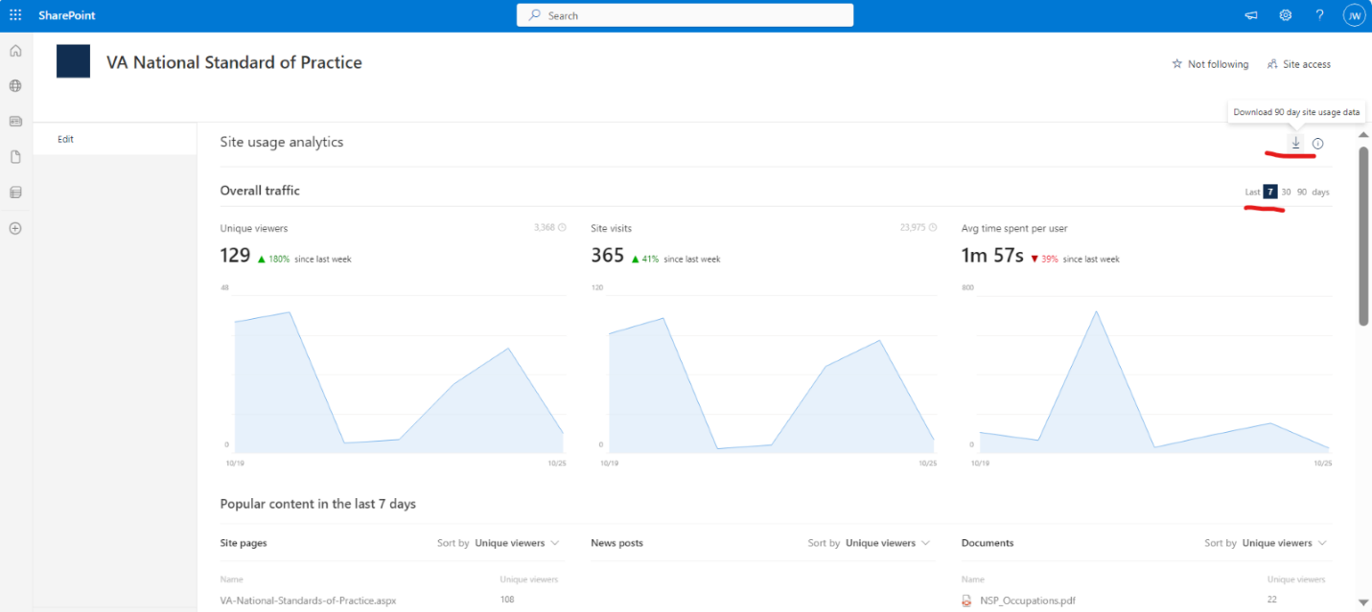
- Input the downloaded data into the SharePoint data - TEMPLATE - Power BI Report.xlsx.
  - Add the unique viewers by (individual) days for the last 7 days (from the report) to the overall traffic tab in the template.
  - Use the popular content tab (unique viewers last 7 days) to update the SP Page View tab in the template.
  - Place the files extracted for that week in the NSP VA Employee Website folder under the appropriate month’s folder.
    - At the start of each new month, move the prior month’s folder into the “archive” folder.

Pulling Subscriber Data
- Go the GovDelivery dashboard.
- Select “Subscribers” and click on CSV. (Figure 9)
Figure 9
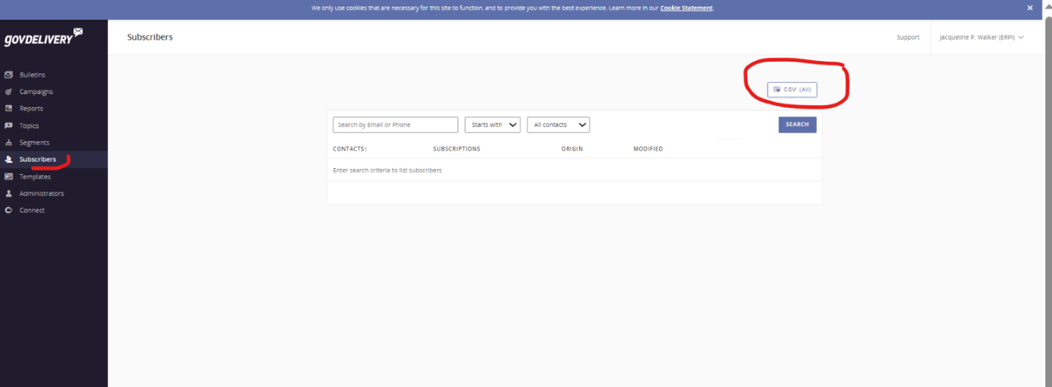
- Download and save file as “Newsletter Subscribers Month_Day_Year” and compare it to the previous week file to determine if there are noticeable differences or concerns, such as a significant decrease in the number of subscribers from the week before.
- Place the file in the “Subscriber Data” folder on SharePoint.
  - Include the link to the file extracted in the takeaways email sent to the dashboard team.

Retrieving Newsletter Performance Reports
- On to the GovDelivery Dashboard and select “Bulletins”. (Figure 10)

Figure 10
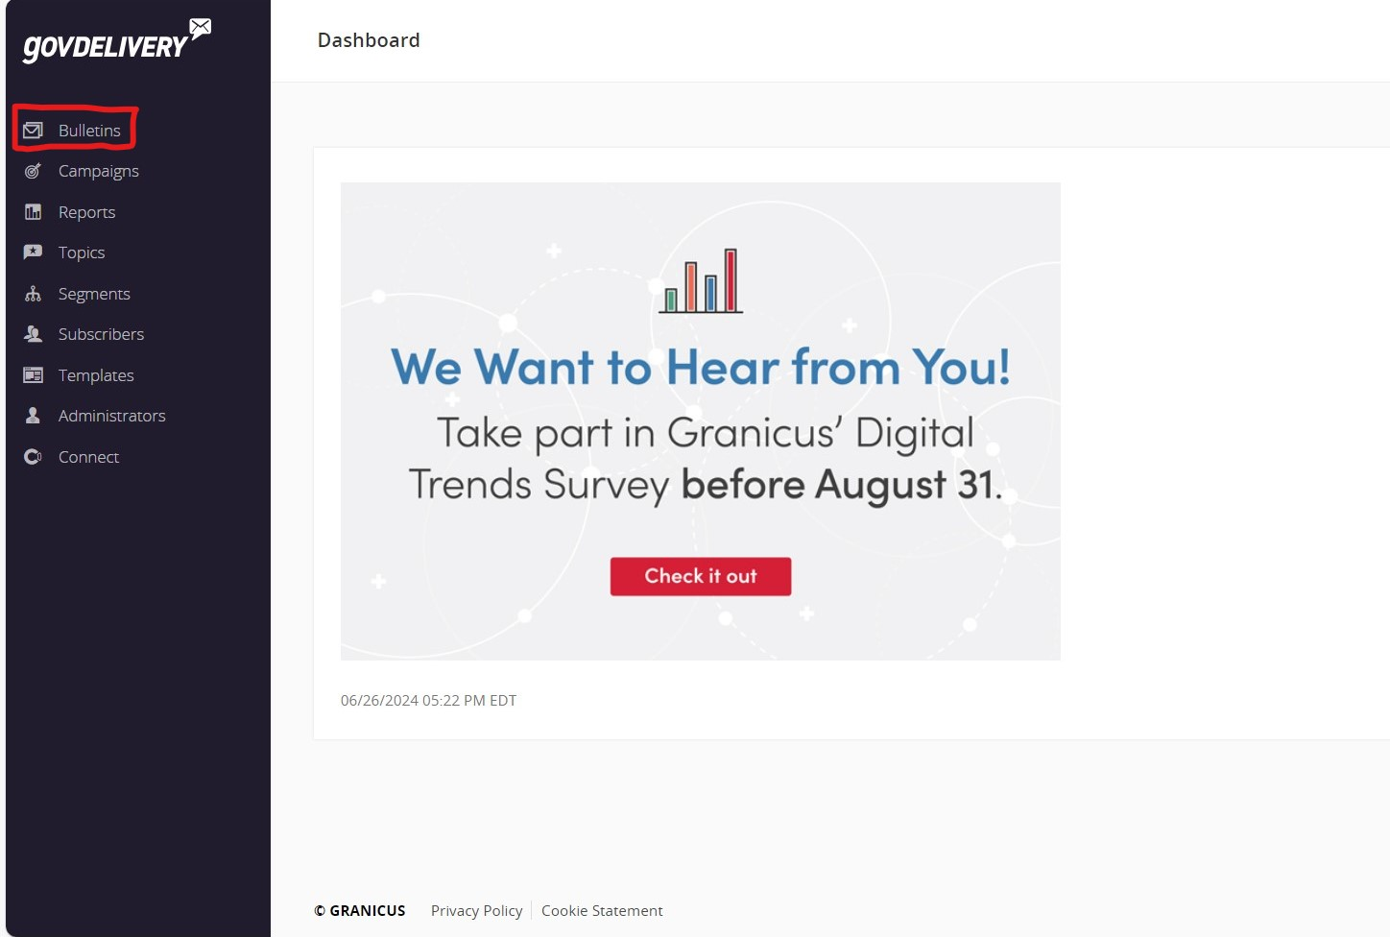
- Select “sent” from the top menu. (Figure 11)
Figure 11
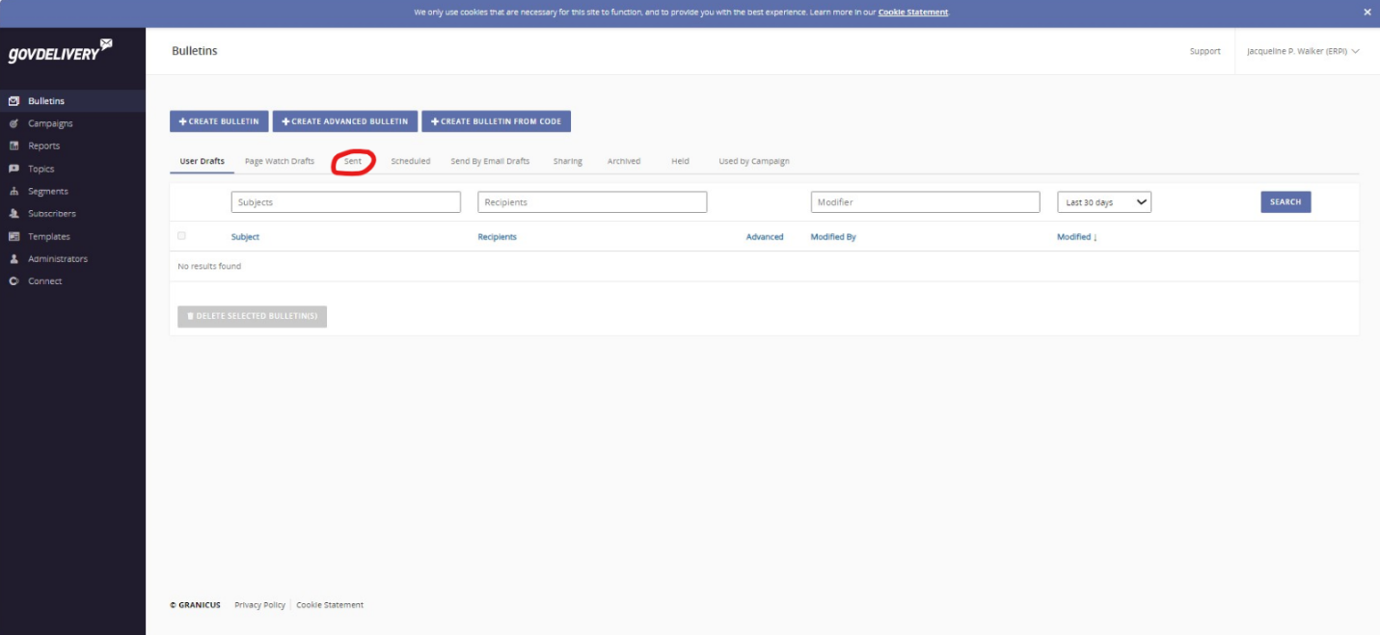
- Find the bulletins from the last week based on “Subject,” “Sent By,” and “Sent” date.
  - Click “View Report.” (Figure 12)
Figure 12
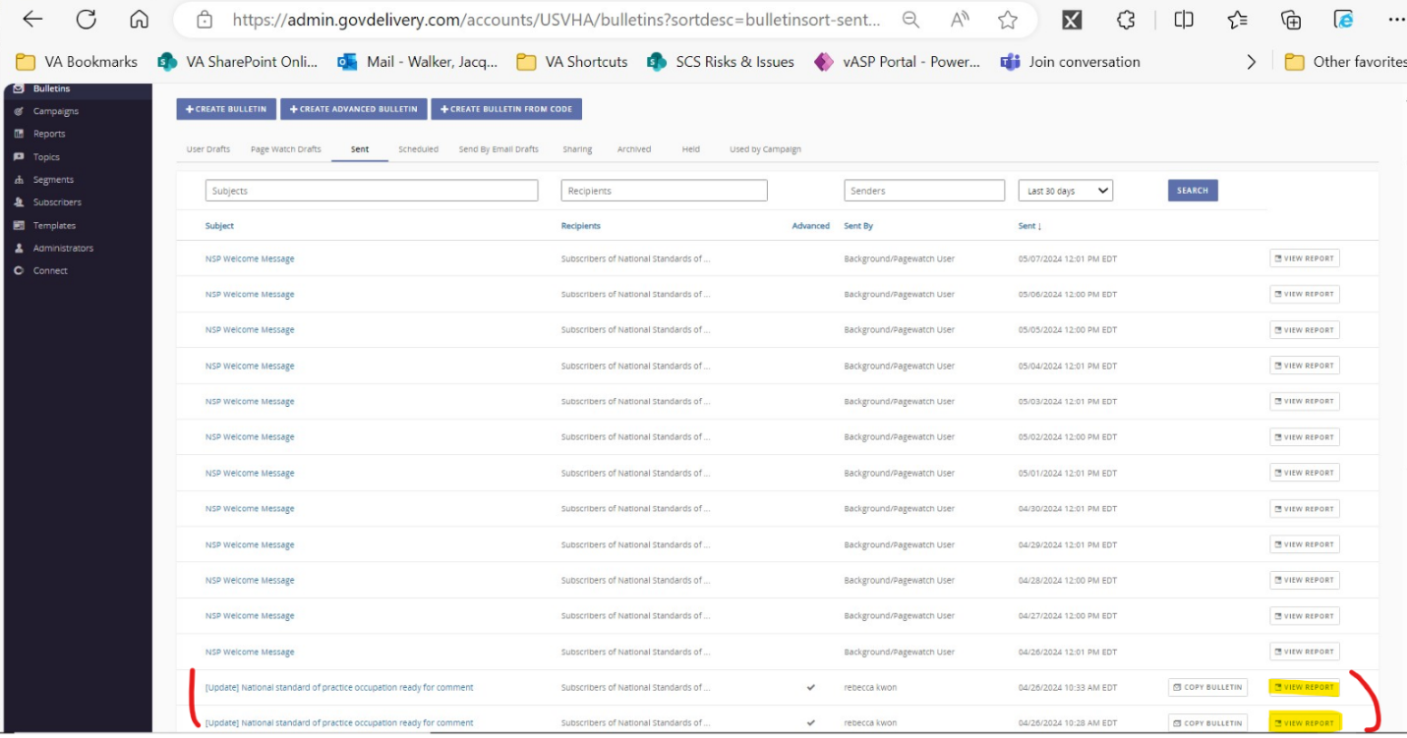
- View the report data on screen or select “PDF” to download a copy of the report. (Figure 13)
Figure 13
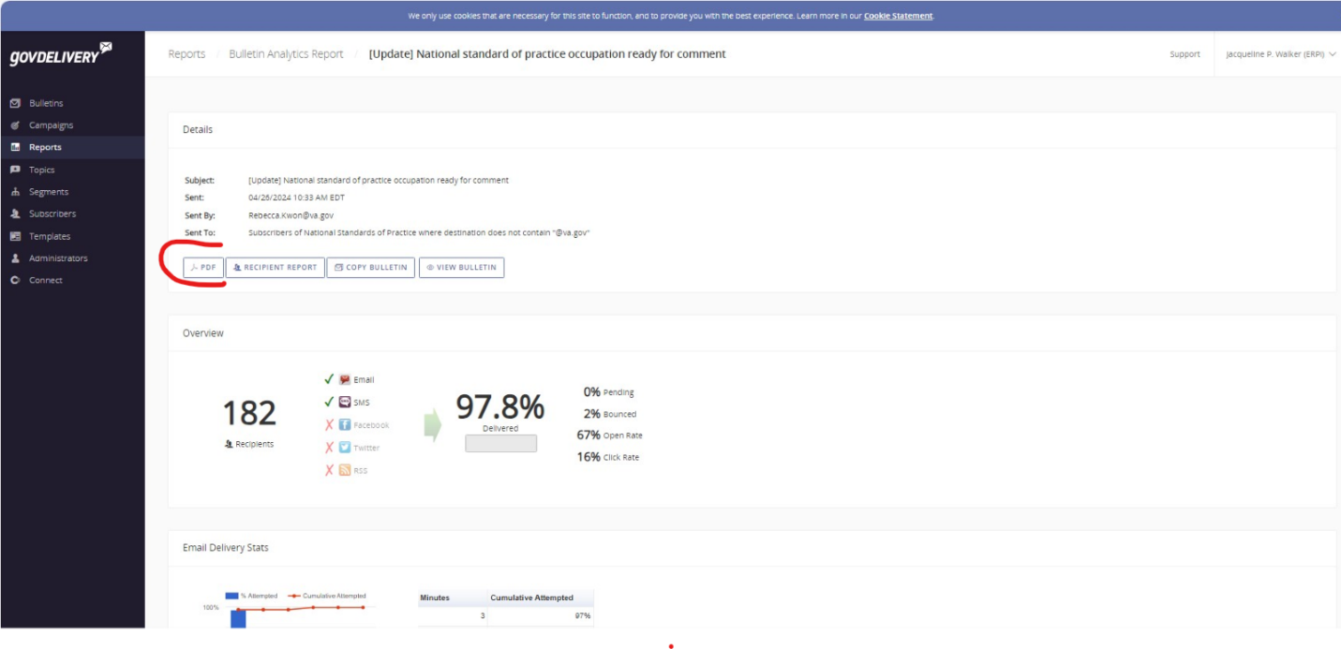
- Use the above data to update the Key Takeaways, as described in the next section.

Updating Takeaways
The following information is sent to Curtis Sun (and CC the rest of the communication’s team) weekly on Tuesdays.
- Attach the link to the uploaded Subscribers Report.
- NSP Employee SharePoint
- XX site visits over the last 7 days (XX% increase/decrease from the prior 7 days). Data can be found on the “overall traffic” tab of the Employee SharePoint report.
- XX unique viewers over the last 7 days (XX% increase/decrease from the prior 7 days.) Data can on the “overall traffic” tab of the Employee SharePoint report.
- Most popular pages (last 7 days):
  - Home page: XX unique views
  - Resources page: XX unique views
  - Frequently Asked Questions page: XX unique views
  - Comment Summary Report page: XX unique views
  - Providing Feedback page: XX unique views
- Most popular documents (last 7 days):
  - Copy and Paste the document titles of the top 3 to 5 most read documents that week.
  - Example: NSP_Occupations_July2024_508.pdf: 11 unique views
- NSP Public Website
- XX site visits over the last 7 days (XX% increase/decrease from the prior 7 days).
  - NOTE: Data is found on the Google Analytics Dashboard, it no longer is highlighted in the downloaded report.
- XX unique views over the last 7 days (XX% increase/decrease from the prior 7 days).
  - NOTE: Data is found on the Google Analytics Dashboard, it no longer is highlighted in the downloaded report.
- Most popular page (last 7 days):
  - NOTE: Most popular pages is determined by selecting the pages with the highest unique page views, however the below six are the most regularly accessed pages each week.
  - Home: XX unique views
  - FAQ: XX unique views
  - Providing Feedback: XX unique views
  - Resources: XX unique views
  - About: XX unique views
  - Summary of Feedback: XX unique views
- NSP Newsletter Performance
- Data found in in bulletin reports from Figure 13.
- Include the following in the weekly email to the Dashboard Team based on newsletter type:
  - VA Employee Newsletter:
    - Sent count, Delivered (count and percentage), Bounced count, Open Rate (count and percentage), Click Through Rate (count and percentage)
  - Public Newsletter:
    - Sent count, Delivered (count and percentage), Bounced count, Open Rate (count and percentage), Click Through Rate (count and percentage)
Example of Key Takeaway email to Curtis Sun:

