Employee SharePoint and Employee Participation SharePoint
NSP Posting Standard Operating Procedures

Contents
1. Introduction 1
2. Updating the Employee SharePoint when NSPs are posted for commenting 2
2.1. Preparing the Employee SharePoint prior to NSP Posting 2
2.2. Finalize NSP Posting – Publish Employee SharePoint updates morning of NSP Posting 6
2.3 Updating the Employee SharePoint when NSPs are closed for commenting 7
3. Updating the Employee Participation SharePoint when NSPs are posted for commenting 7
3.1. Preparing the documentation for the Employee Participation SharePoint prior to NSP Posting 7
3.2. Updating the Employee Participation SharePoint on the day of NSP Posting 8
3.2.1. Updating the number of NSPs open for commenting 9
3.2.2. Updating the policy information for NSPs open for commenting 10
4.2.3 Adding occupation buttons and linking to commenting form 14
4.2.4 Finalizing and Saving Changes to Production 17
3.3. Updating the Employee Participation SharePoint when NSPs are closed for commenting 18
5. Questions and Contacts 19

Introduction

The Employee SharePoint is an internal resource which provides VA employees with information regarding the national standard of practice (NSP) initiative. This website outlines the purpose of NSPs, provides resources to help employees better understand the initiative, find impacted occupations, stay abreast of progress and updates, shares NSPs available for comment, and provides guidance how to provide feedback on posted NSPs.

The Employee Participation SharePoint is a webpage dedicated to collecting feedback from employees when NSPs are available for commenting. This site provides direct access to the commenting form for each of the occupations posted for feedback and includes clarification on the response options available for commenting.

When NSPs are posted (opened) the contractor NSP Communication team is responsible for updating the Employee SharePoint and the Employee Participation SharePoint with the relevant information to support collecting feedback. Also, when the feedback period ends and NSPs are closed for commenting the team must update these SharePoint pages accordingly. The remainder of this document details the required steps for completing updates.

Updating the Employee SharePoint when NSPs are posted for commenting
Follow the steps outlined below to support the posting of NSPs opened for commenting. Updates should be prepared (entered in draft and shared for approval) approximately 1 – 2 weeks prior to the posting date. Updates should not be published until the morning (typically by 9 am eastern time) of the stated comment posting date.

Preparing the Employee SharePoint prior to NSP Posting
- Verify the long-form names of the approved occupations as they should appear in the posting.
- Gather the open and close date.
- Ensure the related Step-by-Step guide for using the PowerApp commenting form is up to date to support employees provide feedback. Upload the current version to the Resources page if needed.
- As soon as occupations are approved for posting enter draft information on the Employee SharePoint page.
  - Access the page at NSP Employee SharePointNSP Employee SharePoint
  - Use the “edit” button in the upper right corner of the screen (Figure 1) to initiate entering the required information.
Note: Do not publish the page until the defined posting date. But you should enter the information, save it as draft, and advise the Comms Lead that the page is ready for review. You may be requested to send screenshots for review by the NSP Contractor Leadership Team or the 10BRAP Client team prior to the posting date.
Figure 1


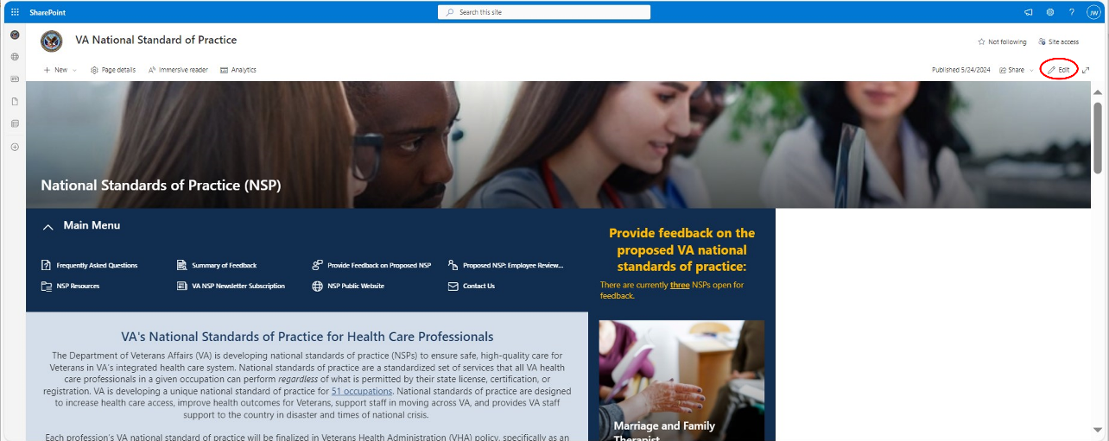
- Change the number of NSPs open for comment and enter information for NSPs that are opening for comment. Currently NSPs are ordered by earliest posting date. If multiple NSPs are posted at the same time, they are listed alphabetically. (see Figure 2).
Figure 2
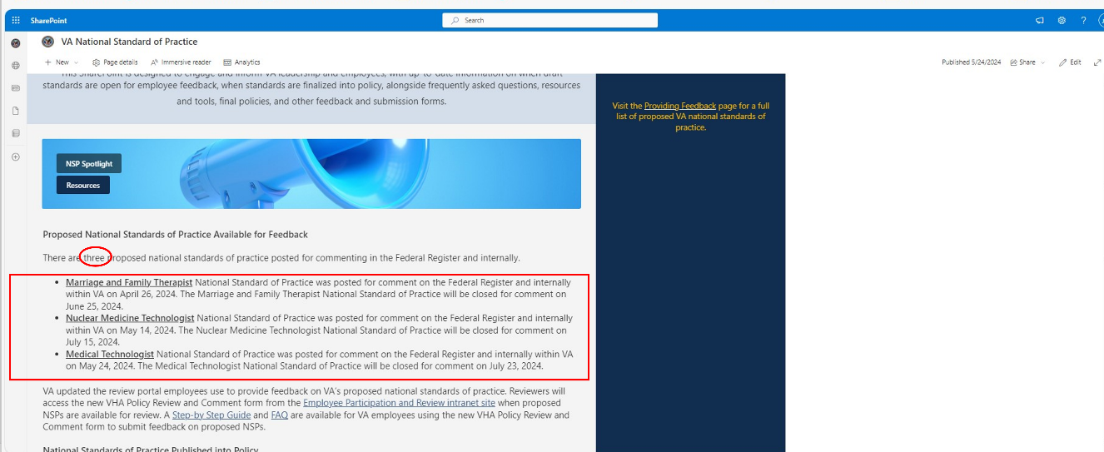
  - Mirror the language and attributes displayed in Figure 2. Occupations are not linked to any page or document.
Note: If dates are not available when information is being prepped use placeholder language (e.g., May xx, 2024)
- Add a “Hero” with representative graphic, Occupation Name and “Provide Feedback” attribute for each NSP. NOTE: The occupation name, “Provide Feedback,” and graphic should all link to the NSP Participation & Review SharePointNSP Participation & Review SharePoint.
- Link each of the sections in the red boxes in Figure 3 to the NSP Participation & Review SharePoint to provide access to the commenting form.
- Link each of the sections in the red boxes in Figure 3 to the NSP Participation & Review SharePoint to provide access to the commenting form.
Figure 3
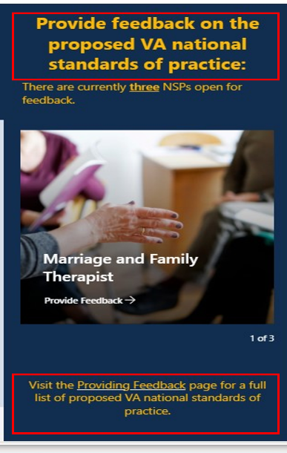

- Next you will need to update the “Provide Feedback on Proposed NSP” page.
- Select the page from the “Home” page menu as shown in Figure 4.
Figure 4
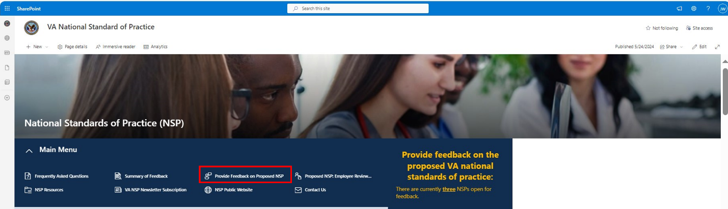
- On the “Provide Feedback on Proposed NSP” page, add the occupation name and commenting date in “National Standards of Practice Open for Feedback” table as shown in Figure 5.
Figure 5
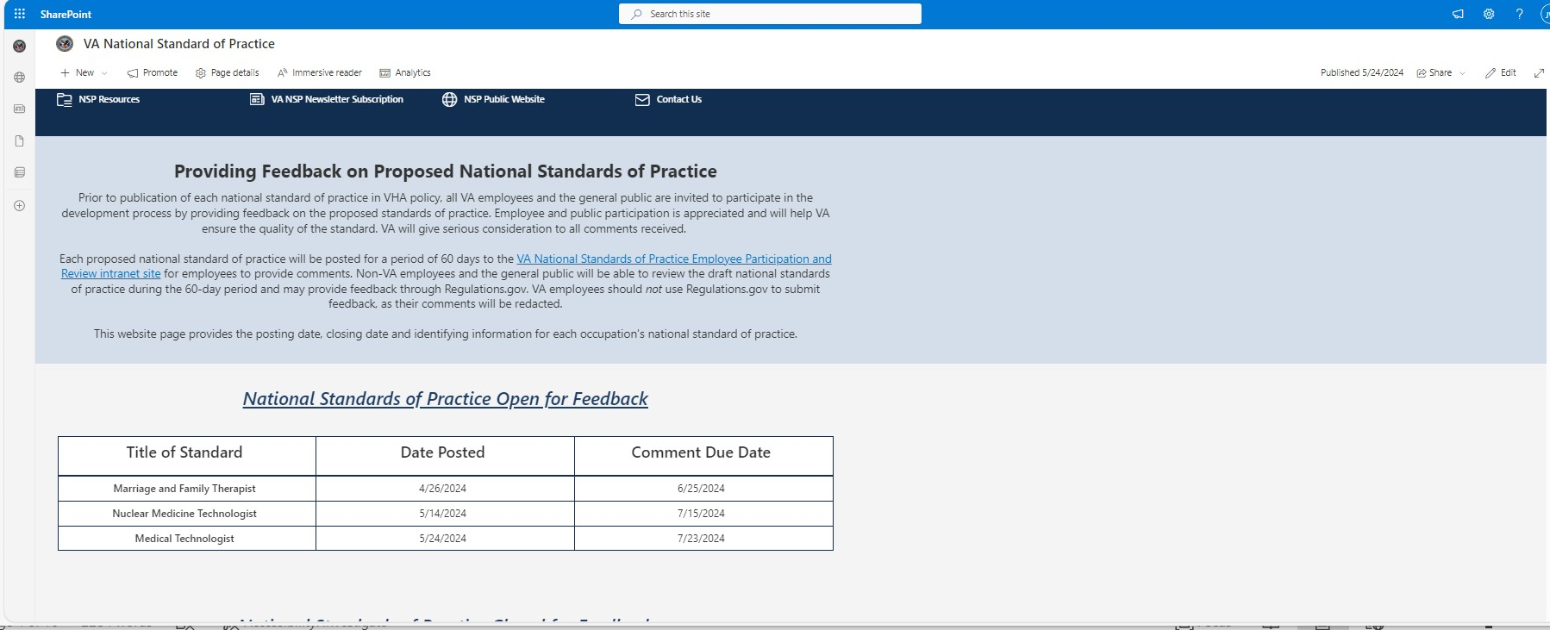
- Remove the occupation name from the “National Standards of Practice in Development” list as shown in Figure 6.

Figure 6
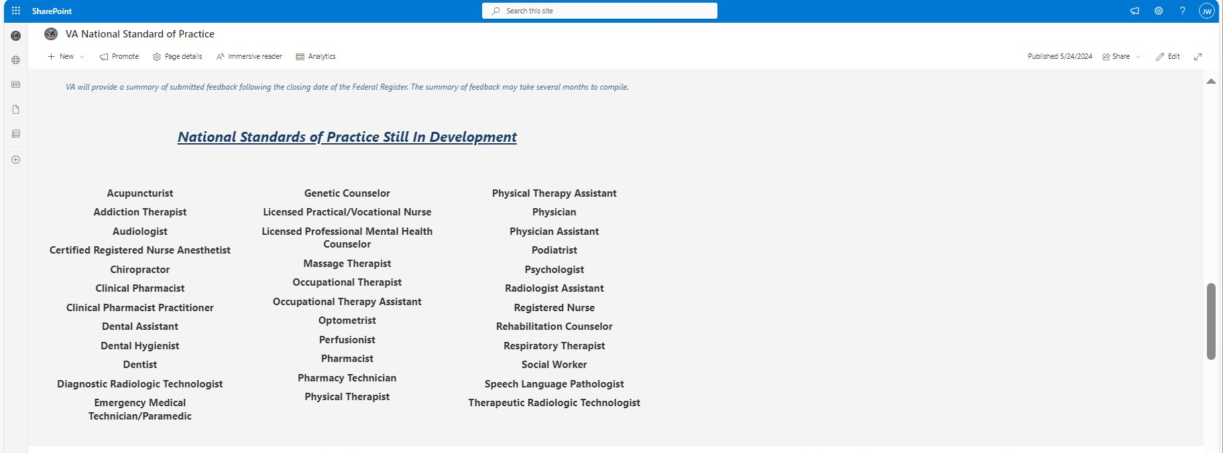
- Do not publish the site/page instead save the changes in draft by selecting the “Save as draft” button highlighted in (Figure 7). DO NOT select the “republish” button.
Figure 7
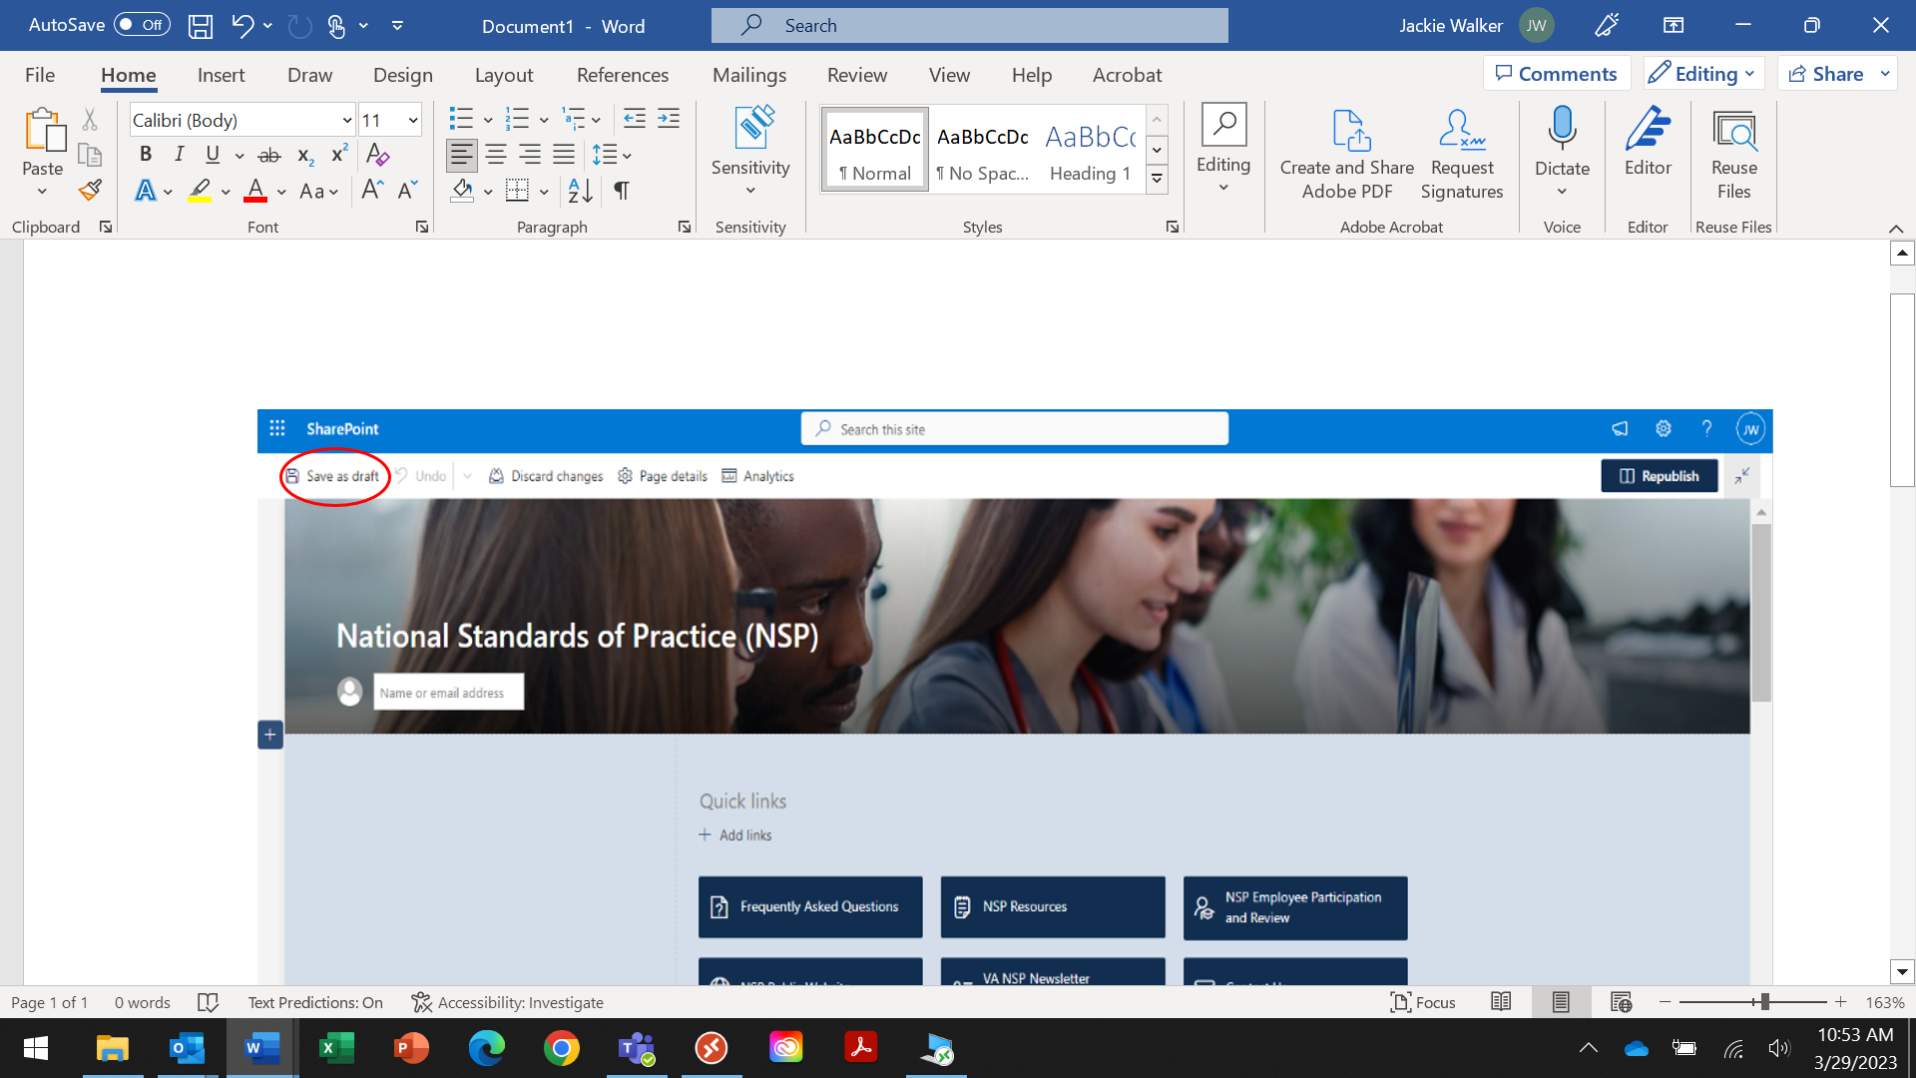

Finalize NSP Posting – Publish Employee SharePoint updates morning of NSP Posting
The Employee SharePoint should be published with the approved information for NSP commenting by 9 am (eastern) on the date the Federal Register notices are published.
Secure verification of direction to publish site from Comms Lead and Project Management team on the morning of postings:
- Access the Employee SharePoint page using instructions noted in section 2.1 (for editing the site).
- Review all entered information:
  - NSP/occupation names
  - Language, spacing, closing date on each entry
  - Confirm all links are in place and direct the user to the expected page
- Once all information is verified, use the “republish” button on both “Home” and the “National Standards of Practice Open for Feedback” pages to publish the site. See example in Figure 8.
Figure 8
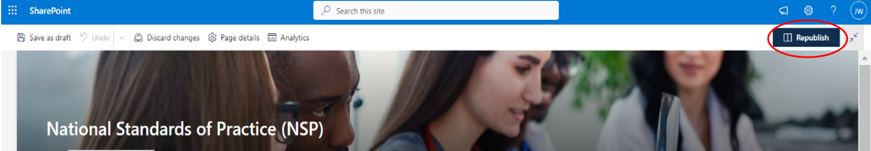
- You should then see confirmation that the site is published (Figure 9).

Figure 9
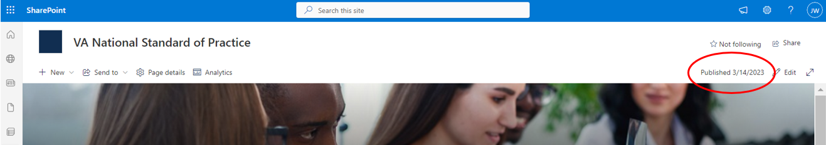

Updating the Employee SharePoint when NSPs are closed for commenting
When the commenting period closes for an NSP, the information for the occupation should be :
- Removed from the “Home Page” of Employee SharePoint (including graphics, and links).
- Moved from the “National Standards of Practice Open for Feedback” table to the “National Standards of Practice Closed for Feedback” table on the “Provide Feedback on Proposed NSP” page.
The number of NSPs open for feedback should be updated everywhere it appear on the “Home Page.”

Updating the Employee Participation SharePoint when NSPs are posted for commenting
Follow the steps outlined below to support providing employees access to commenting on NSPs. All required information to support updating the Employee Participation page is developed in a WORD document. Once this information is approved it is held and used to make updates on the morning of NSP postings to coincide with updates to the Employee SharePoint (typically by 9 am eastern time) of the stated comment posting date.

Preparing the documentation for the Employee Participation SharePoint prior to NSP Posting
- Verify the long-form names of the approved occupations as they should appear in the posting.
- Gather the open and close date.
- Review proposed NSP draft content or confer with Document Managers to identify the certifying or registration body whose standards the NSP will be consistent with.
- Create a WORD document similar to example below, revising or adding the highlighted information (number of NSPs open for commenting and detail information such as occupation date, open closing date and standards being adopted).
Note: Number of NSPs open for commenting should reflect those currently open for feedback plus those being prepared for posting.
  - Submit WORD document to Comms Lead for review and approval,
  - Once the Comms Lead has reviewed and approved, forward to the NSP ConrMegan Hislop for review and approval.
  - Make changes to WORD document based on feedback and resubmit for approval.
  - When information is approved, await posting date to set up and publish Employee Participation site.
- Contact the PowerBI Team to acquire the correct link (URL) to the commenting form for each NSP.
- Create an occupation button in (see example below) for each NSP that will link to the commenting form for the named occupation using sample prototypes at the following link NSP Review Site Links.pptxNSP Review Site Links.pptx
Example Occupation button:
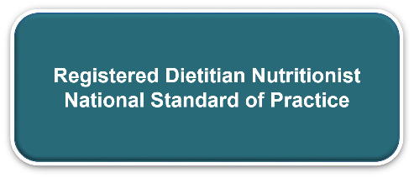

Updating the Employee Participation SharePoint on the day of NSP Posting
The Employee Participation SharePoint should be published with the approved information for NSP commenting by 9 am (Eastern) on the date the Federal Register notices are published. Secure verification of direction to publish site from Comms Lead and Project Management team on the morning of postings:
- Access the Employee Participation page at NSP Participation & Review SharePointNSP Participation & Review SharePoint.
- Use the “edit” button in the upper right corner of the screen (Figure 6) to initiate entering the required information.
Figure 10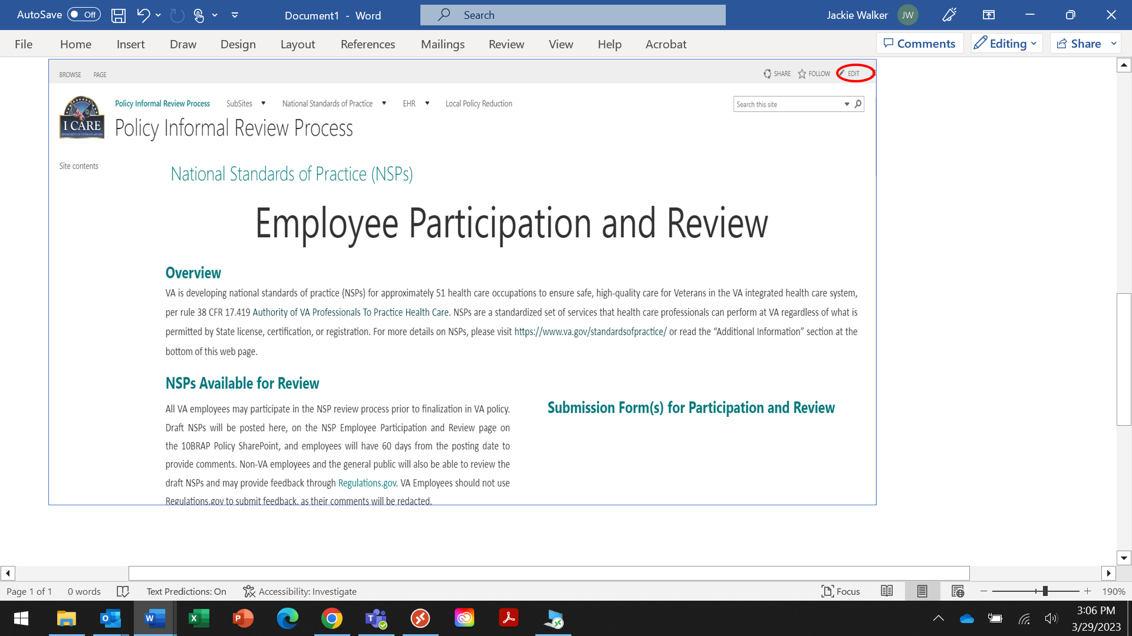

Updating the number of NSPs open for commenting
- Update the number of NSPs open for commenting to reflect the total number of occupations already and remaining open for comment plus those being added for commenting (Figure 11).
  - Keep formatting: bold, italic with font: Body, 13pt

Figure 11
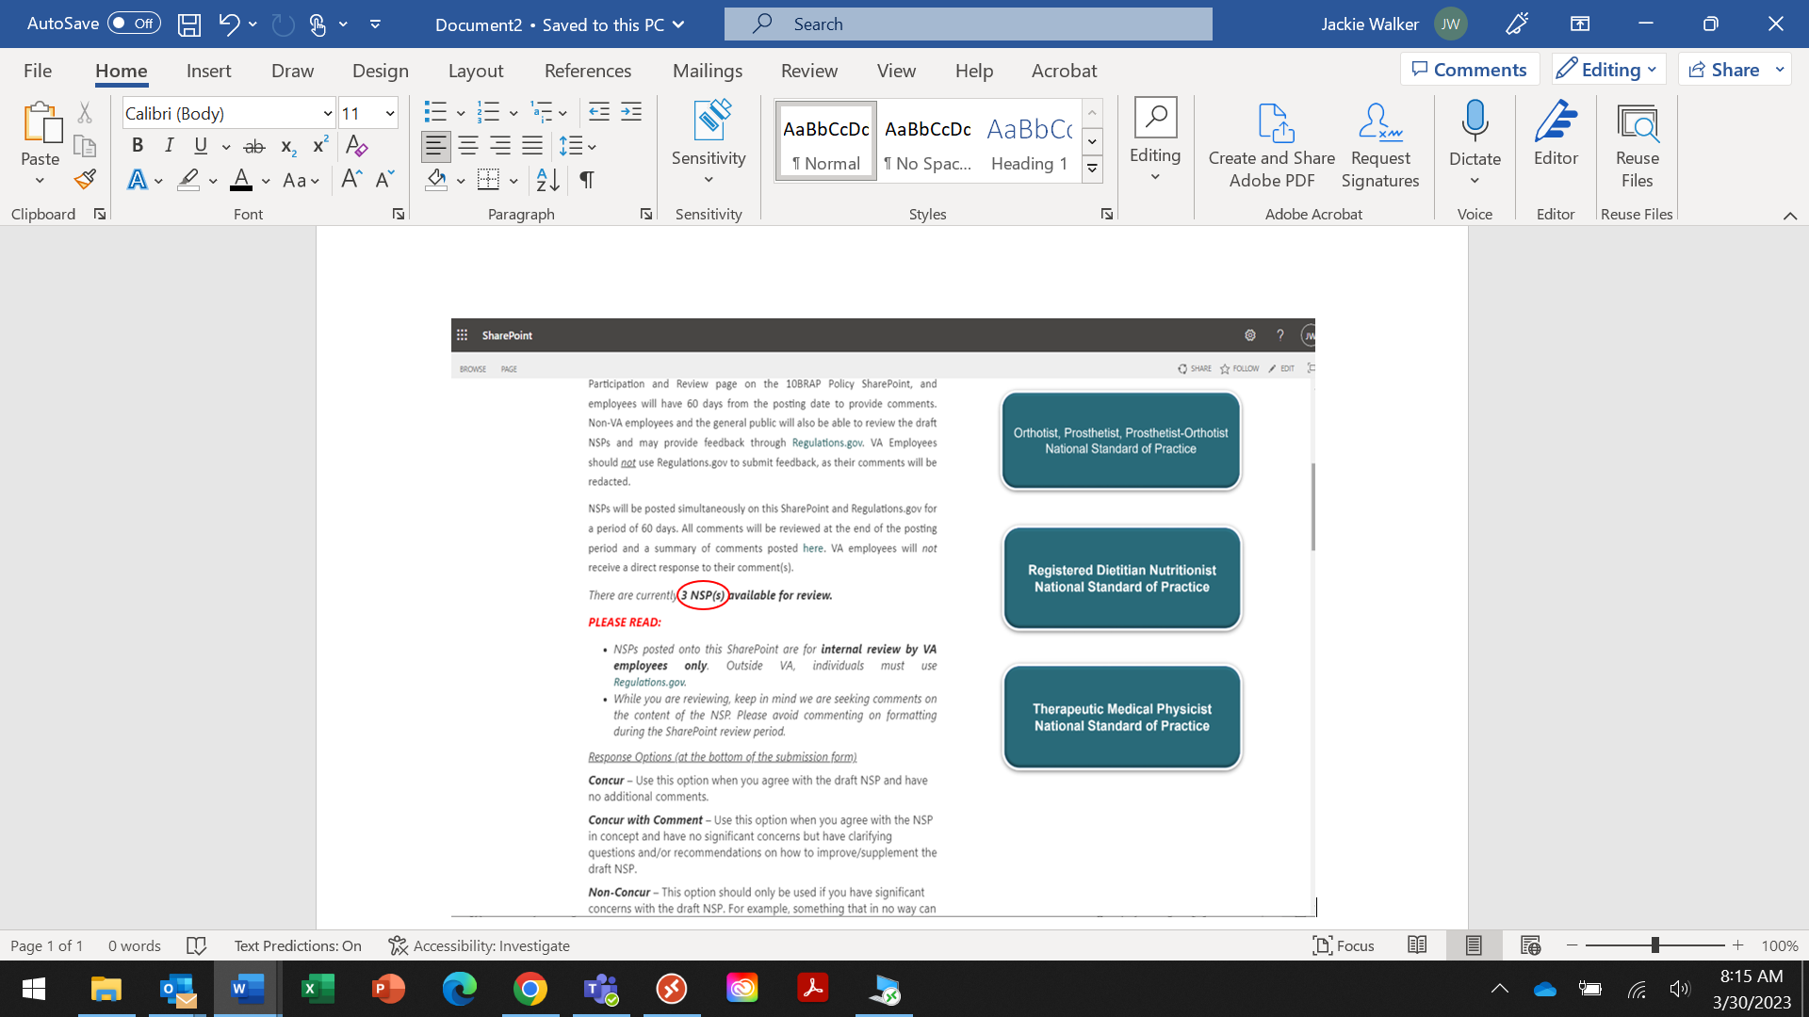

Updating the policy information for NSPs open for commenting
- Cut and paste the policy information for each NSP (from the approved WORD document noted in section 4.1) below the Response Options section of the form (Figure 12).
- Cut and paste the policy information for each NSP (from the approved WORD document noted in section 4.1) below the Response Options section of the form (Figure 12).
  - Information should be ordered alphabetically based on occupation name, within closing date.
  - Set font to Body, 13pt for the all the information copied.
Figure 12
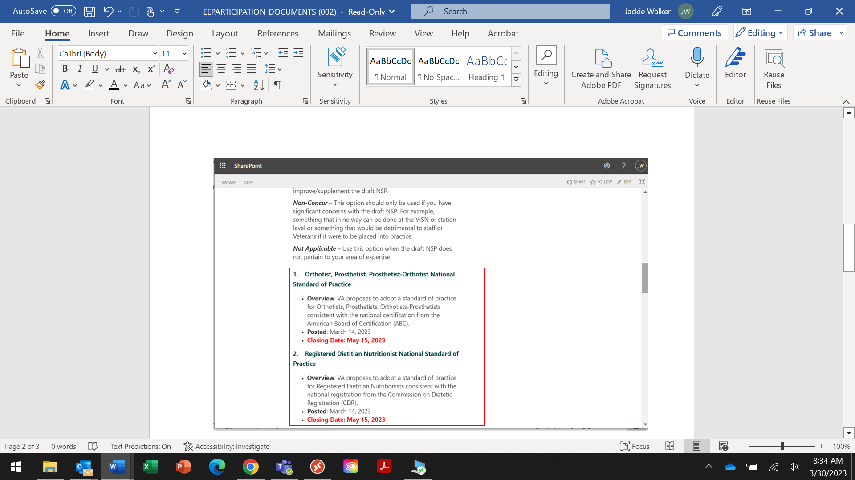
Note: You can cut and paste in the information for all the NSPs at one time, but you will need to format the information for each individually.
- Format the contents for each NSP.
Note: You will need to perform the formatting steps separately for each occupation/NSP name. Once the link is entered the system will update the color of the occupation name to the required TEAL shade. If it does not use the following setting to get the correct color: #03787C
  - Highlight an NSP name and select the link button on the menu (Figure 13).

Figure 13
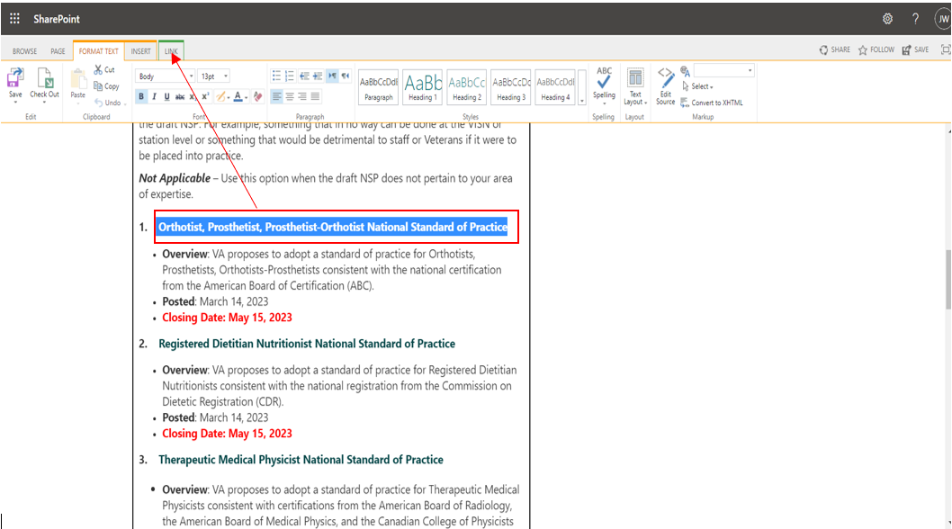
  - Select “link from address” (Figure 14).

Figure 14
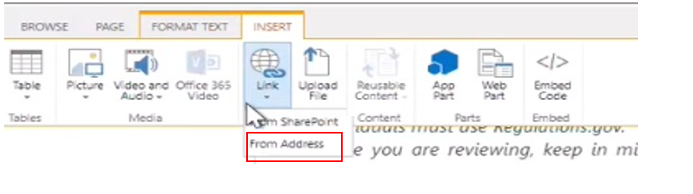
    - Enter the link to the commenting form provided by the PowerBI Team for the highlighted NSP (Figure 15)
Figure 15
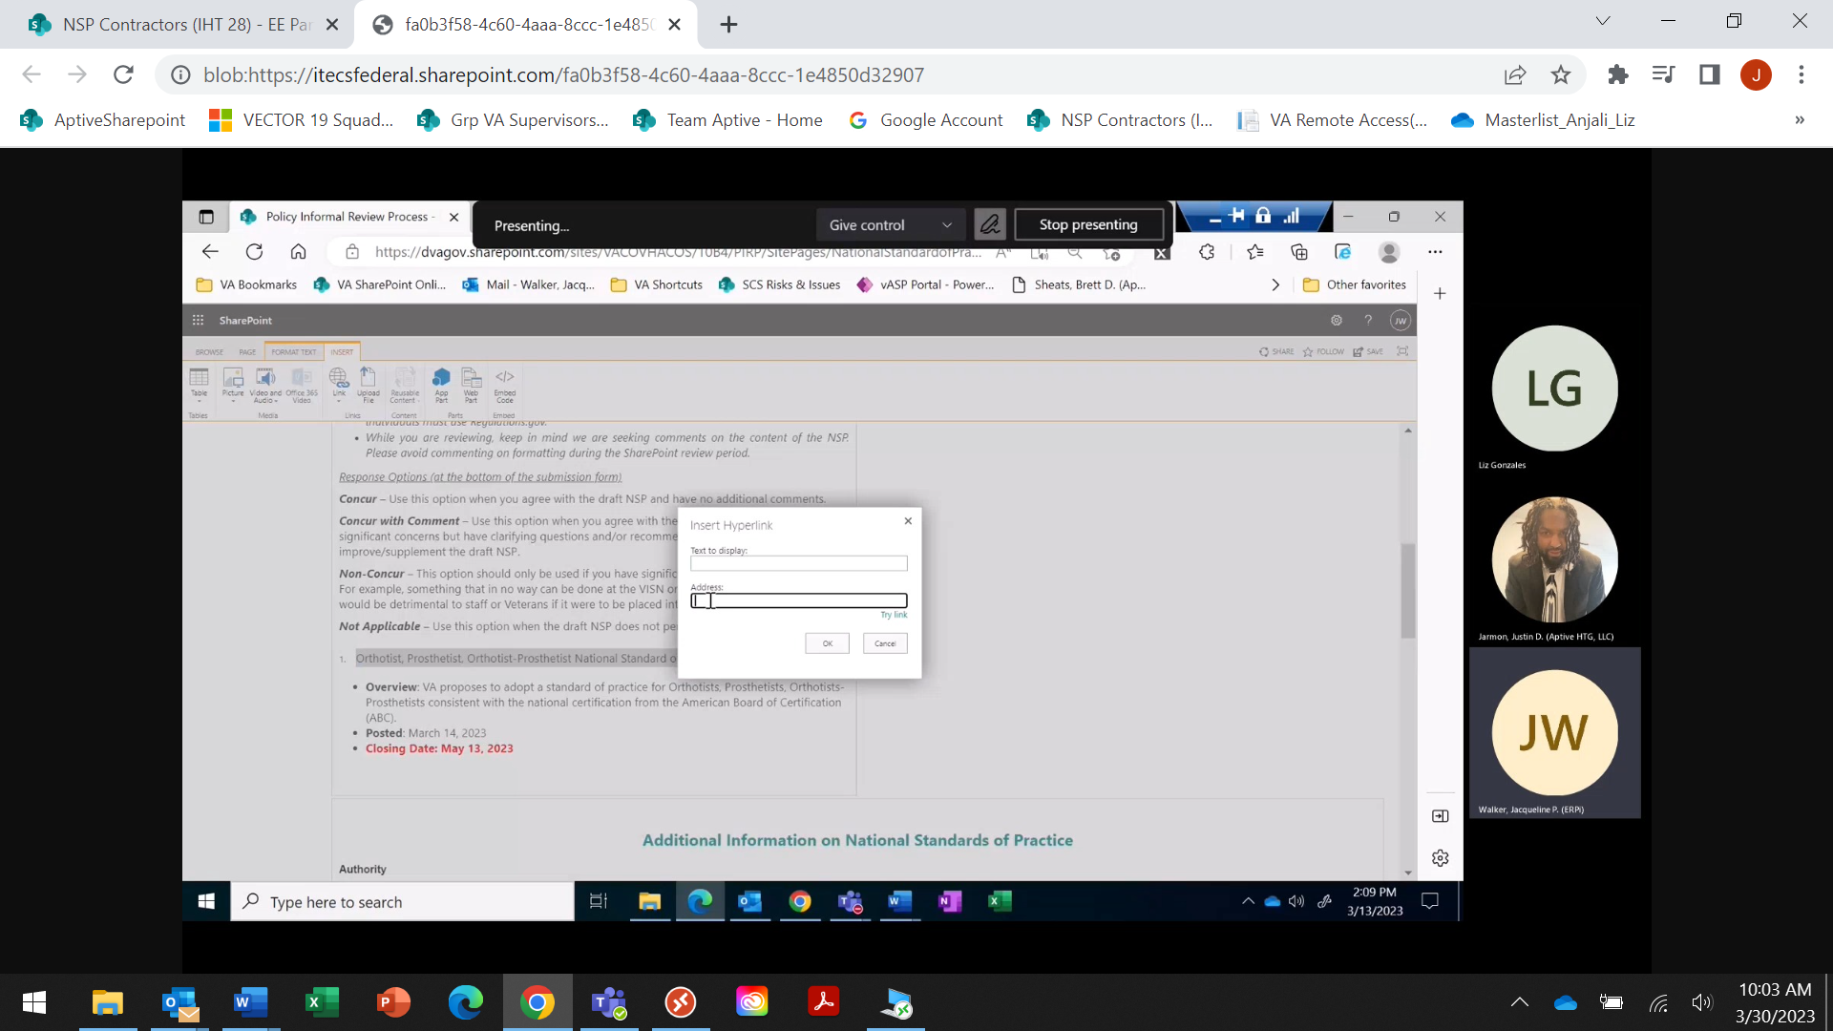
    - Select “Open in new tab” (Figure 16).
    - Once the link is entered select the PAGE button on the menu to continue editing the list of NSPs.

Figure 16
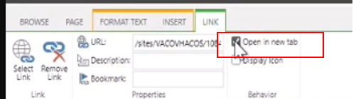
- Format the bulleted information for each NSP:
  - Highlight the bulleted section and click the bullet icon (Figure 17) in the menu twice.
  - Bold the numeric identifier in the left margin next to each NSP name.
  - Bold the words: “Overview” and “Posted.”
  - Bold all language on the closing date line and change the font to red.

Figure 17
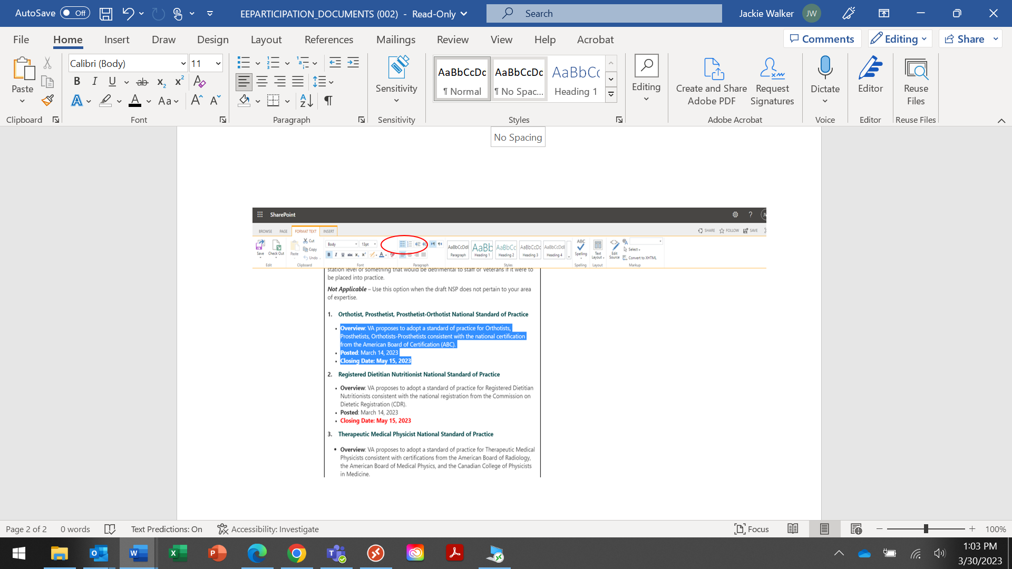

Adding occupation buttons and linking to commenting form
- In edit mode position your cursor under the "Submission Form(s) for Participation and Review” heading and select “Picture” then “From Computer” (Figure 18).
Figure 18
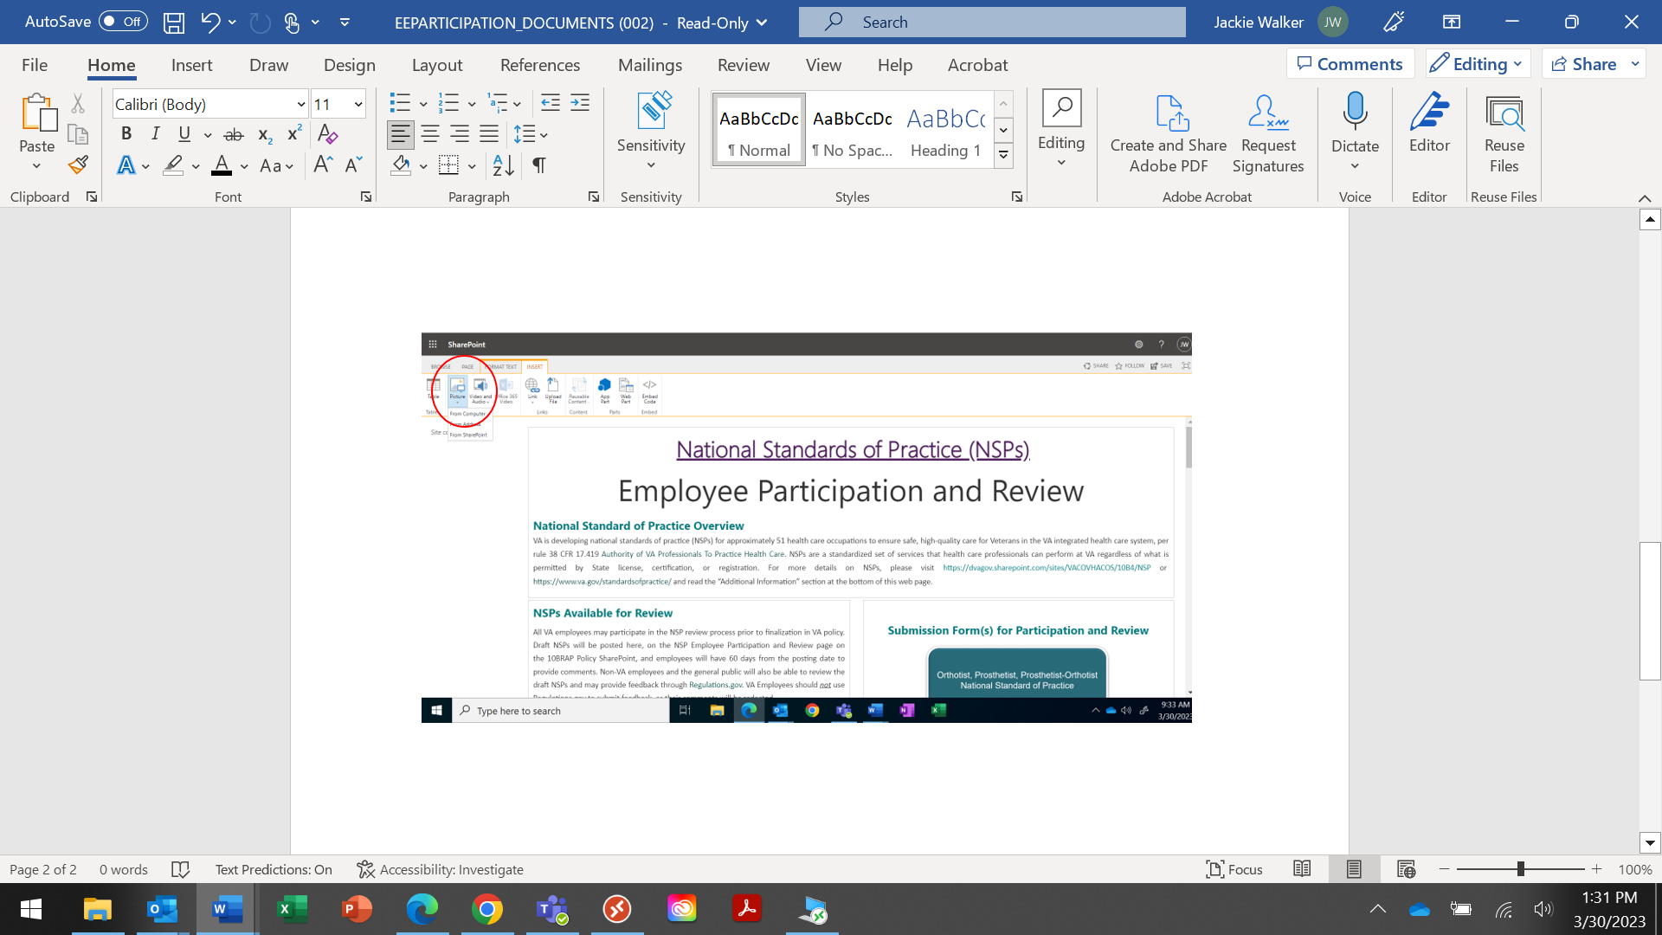
- Follow all prompts to upload the file from your computer and click “OK” (Figure 19).
Note: This will be followed by another upload image form. Simply click “Save” on this form, without entering or changing any information (Figure 20).

Figure 19
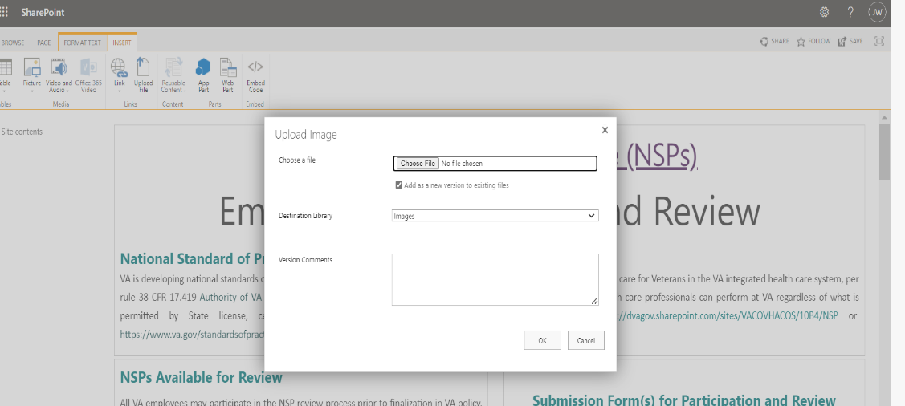
Figure 20
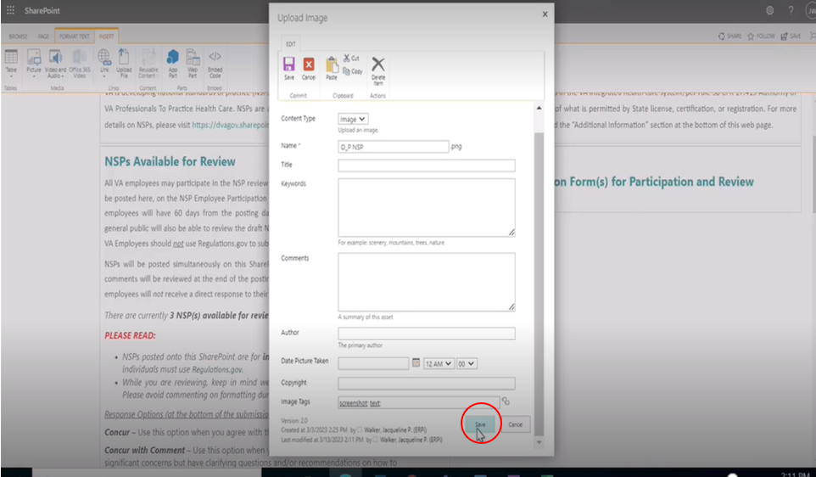
Note: The occupation button will appear extremely large in size. Remove the checkmark from the “Lock aspect ratio” box and set the size to 325 “Horizontal” and 165 “Vertical” and then add the checkmark back. This should size the button accordingly. See Figures 21a and 21b.

Figure 21a
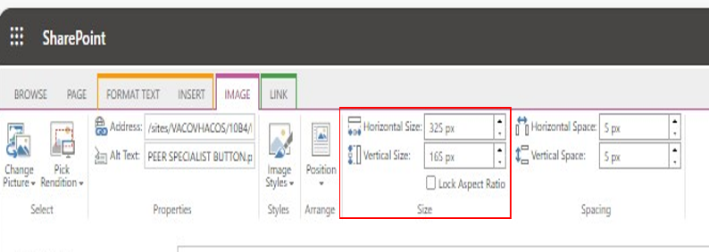
Figure 21b
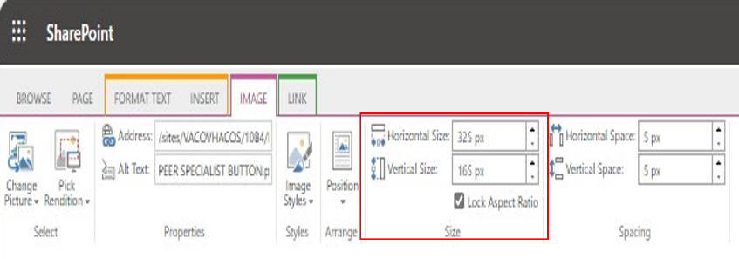

- Once the occupation button is resized, select “Page” to continue editing.
  - Highlight/select the occupation button and link to the commenting form (Figure 21c).
Figure 21c

Finalizing and Saving Changes to Production
  - Once all occupation buttons are linked select “Page” to review entries for accuracy.
  - If all entries appear as desired, click the “Save” button in the right-hand corner of the menu (Figure 22).
  - The page will be published and ready for commenting support.
Figure 22
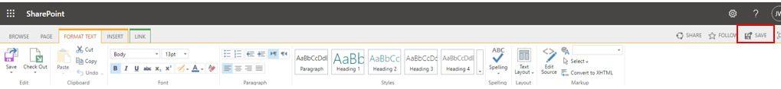
- Note: Typically, the “Save” (Figure 23) and “Check Out” (Figure 24) buttons in the left-hand corner of the menu are not utilized but their high-level function are noted below.
Figure 23
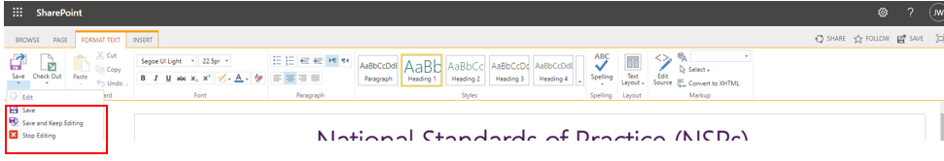
  - Figure 24:
    - “Save” button results in saving/publishing changes and end “edit” session to production similar to the corresponding button on the right-hand corner of the menu.
    - “Save and Keep Editing” will publish all changes already entered to production but keep the user in “edit” mode to continue making changes.
    - “Stop editing” will end the editing session. If changes were made, the user will be prompted to “save” or “discard” them prior to exiting.
Figure 24
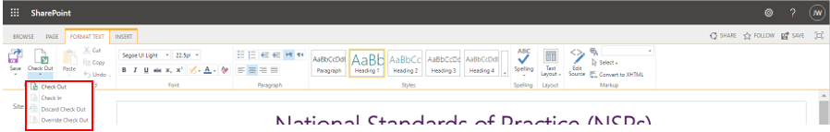
  - Figure 24:
    - “Check Out” restricts editing to only the person that checked out the page.
    - “Check In” removes the “check out” editing restriction.
    - “Discard Check Out” discards any changes made while the page was checked out.
    - “Override” allows one user to check-in page checked out by another user and discard changes.

Updating the Employee Participation SharePoint when NSPs are closed for commenting
When the commenting period closes for an NSP, the information for the occupations should be removed from the Employee Participation SharePoint. Remove information for NSPs closed for commenting by close of business on the day commenting closes.
- Access the Employee Participation page at NSP Participation & Review SharePointNSP Participation & Review SharePoint
- Use the “edit” button in the upper right corner of the screen (Figure 25) to initiate edits.

Figure 25
- Remove policy information and the corresponding occupation button for all NSPs closed for commenting.
- Click “Save” in the upper right-hand corner of the menu to publish the page.

Questions and Contacts
- For questions or access needs related to the Employee SharePoint and Employee Participation SharePoint please contact the Comms Team.
  - The Comms Lead will assign support or request direction from the NSP Leadership Team.

